Assignment 07: Data-Driven Apps

In this “hands-on” activity, you discover more details about creating data-driven web ASP.NET pages. This activity takes about to 6 hours, so plan accordingly!

The activity consists of the following steps:
- Read a book chapter
- Study web resources.
- Create your own demo
- Submit your work to the Canvas site.

Read a book Chapter
Please read Chapter 14 of your textbook, Beginning ASP.NET 4.5 in C#.

Study web resource
Please review the following articles:

1. Microsoft SQL Server
http://www.asp.net/learn/sql-videos/

2. Using ADO.NET
https://csharp-station.com/Tutorial/AdoDotNet

3. ADO.NET command parameters
http://dotnetfacts.blogspot.com/2009/01/adonet-command-parameters.html

4. Modifying Data with Stored Procedures (ADO.NET)
http://msdn.microsoft.com/en-us/library/59x02y99.aspx

Create your own demo
In Module 7, you saw how to both use both SQL views and stored procedures. Now, create a set of pages that use both of these SQL objects.

1. Using the WebDevAssignment07 database on the UW server is-root01.ischool.uw.edu, create a page called Admin.aspx that shows the data exposed by the following views:

SELECT [ClassId]
,[ClassName]
,[ClassDate]
,[ClassDescription]
FROM [WebDevAssignment07].[dbo].[vClasses];

SELECT [StudentId]
,[StudentName]
,[StudentEmail]
,[StudentLogin]
,[StudentPassword]
FROM [WebDevAssignment07].[dbo].[vStudents];

SELECT [ClassId]
,[StudentId]
FROM [WebDevAssignment07].[dbo].[vClassStudents];

SELECT [LoginId]
,[Name]
,[EmailAddress]
,[LoginName]
,[NewOrReactivate]
,[ReasonForAccess]
,[DateRequiredBy]
FROM [WebDevAssignment07].[dbo].[vLoginRequests];

You can use the following connection properties:
Data Source = is-root01.ischool.uw.edu
User ID = CSharp
Password = sql
Initial Catalog = WebDevAssignment07;

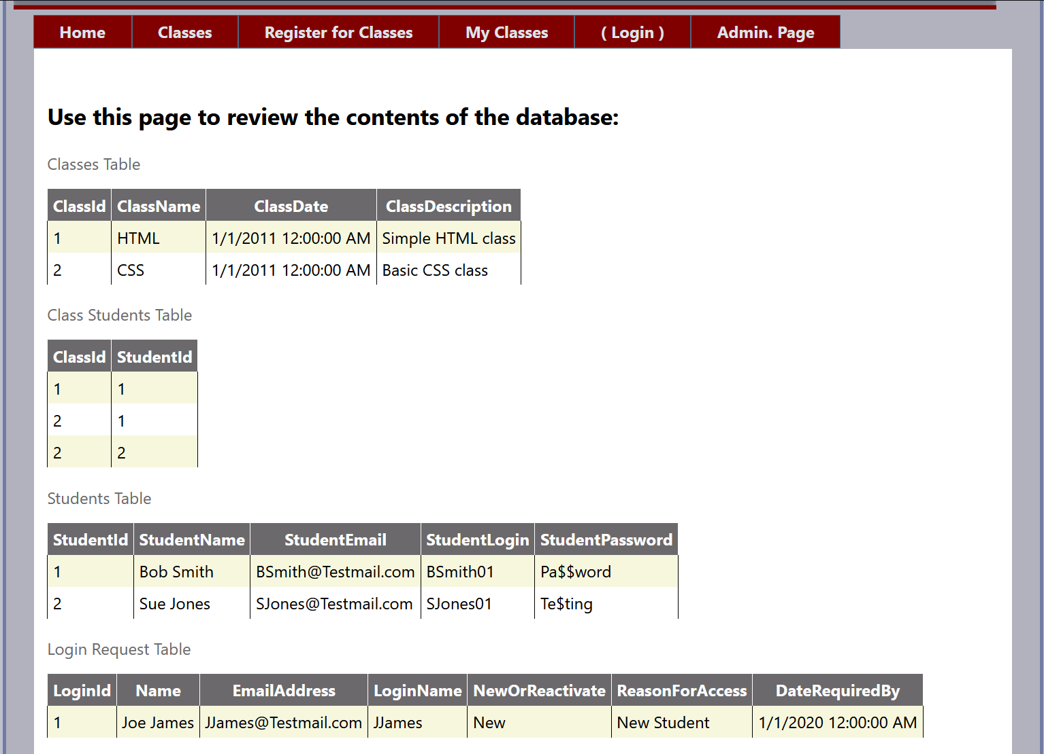

2. Create a page called Login.aspx that creates a session variable with a StudentID when a user enters the correct combination of name and password. Allow access to the Admin page, only if the user is the "Admin."

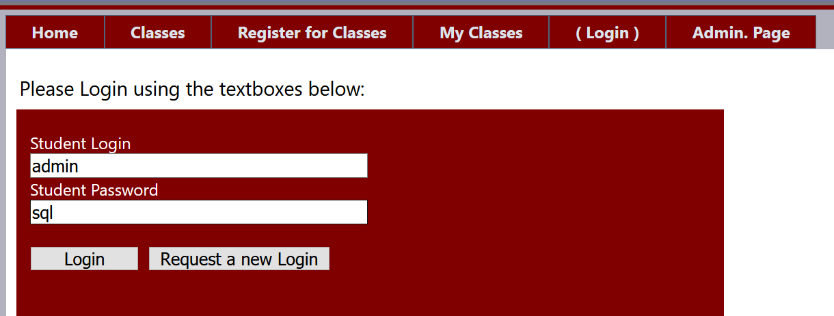

Use the data in the Students table and the pSelLoginIdByLoginAndPassword stored procedure to accomplish this:

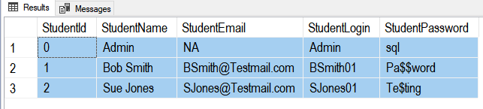

Go
CREATE -- DROP
PROCEDURE dbo.pSelLoginIdByLoginAndPassword(
@StudentLogin nVarchar(50)
, @StudentPassword nVarchar(50)
, @StudentId int Out
)
AS
/***************************************************
Dev: RRoot
Date: Nov, 10, 2011
Desc: This stored procedure outputs a student Id
based on a given login and password
ChangeLog: (Who, When, What)
***************************************************/
BEGIN -- Body of stored procedure:
BEGIN TRY
------------------- Reporting Statement:
Select @StudentId = [StudentId]
From [AdvWebDevProject].[dbo].[Students]
Where [StudentLogin] = @StudentLogin
AND [StudentPassword] = @StudentPassword;
If(@@ROWCOUNT = 0) RaisError('No Login Found', 15, 1);
------------------- Reporting Statement;
RETURN +100
END TRY
BEGIN CATCH
--ROLLBACK TRANSACTION;
Declare @Message nVarchar(1000);
Select @Message = ERROR_MESSAGE();
RAISERROR(@Message, 15, 1);
RETURN -100
END CATCH
END; -- Body of stored procedure;
Go

Submit your work to the Canvas site.
After you complete you your Assignment website, place the resulting files and folders into another folder, both the document and the Visual Studio Solution/Project sub-folder, and turn everything into a single zip file. Then post the zip file on the Canvas website, in the appropriate module under Assignments.
(http://www.wikihow.com/Zip-Files-Together)

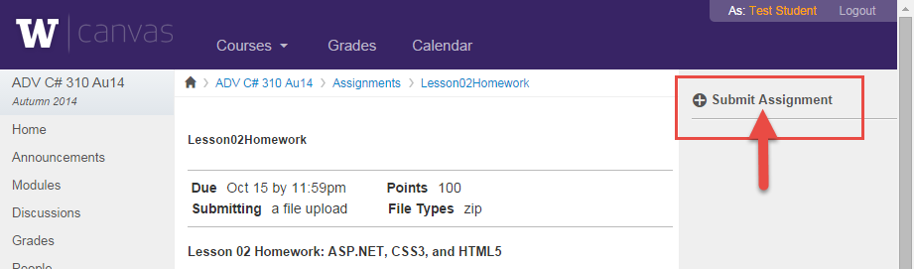

You’re done!!!

